**SQL EXERCISES**

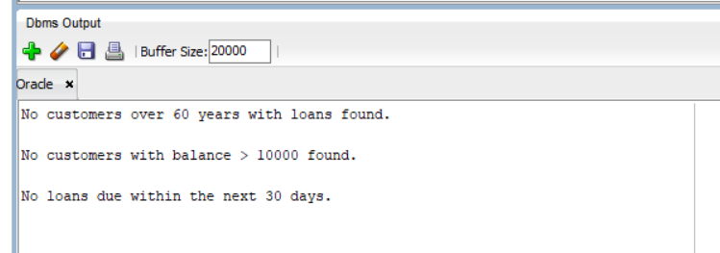**EXERCISE – 1**

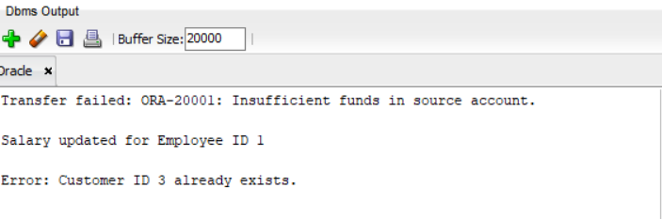**EXERCISE – 2**

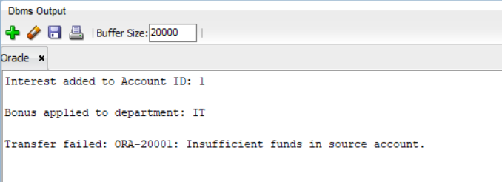**EXERCISE – 3**

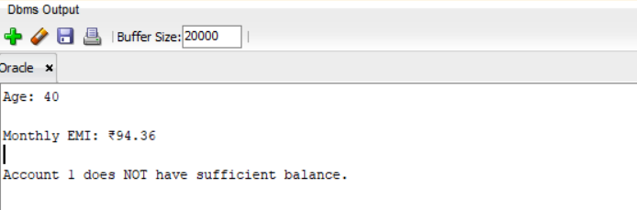**EXERCISE - 4**

**EXERCISE – 5**

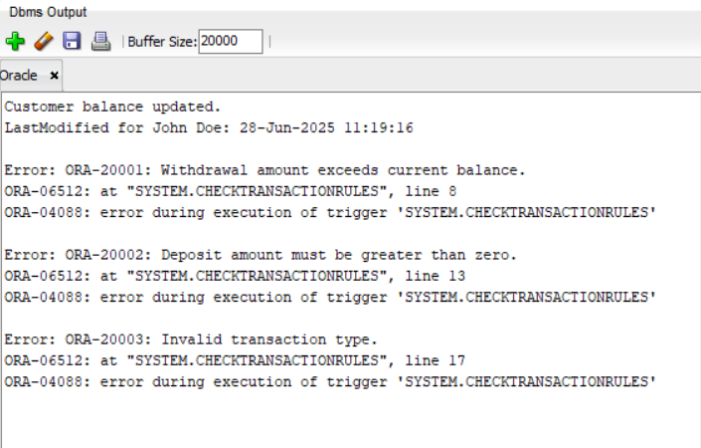

**EXERCISE – 6**

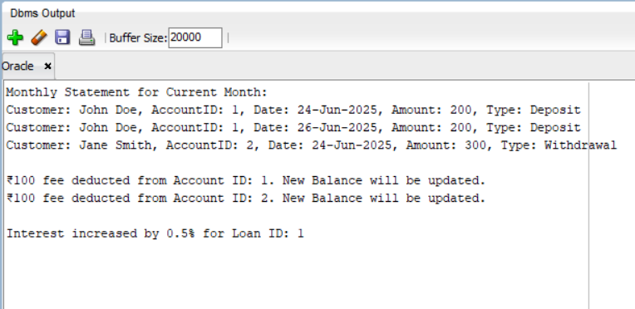

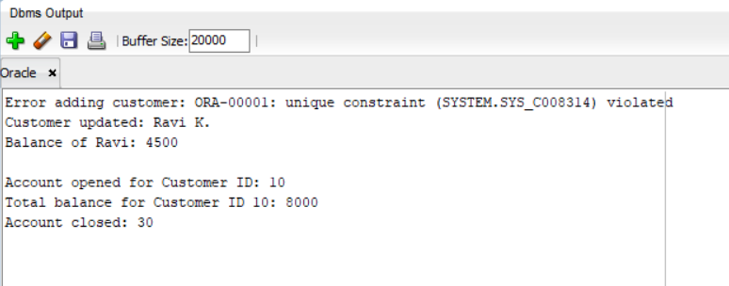**EXERCISE - 7**